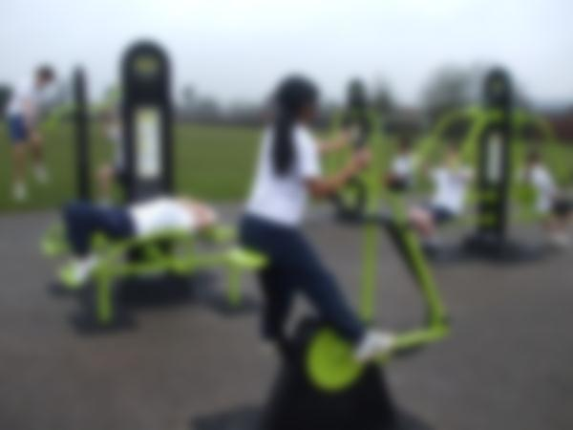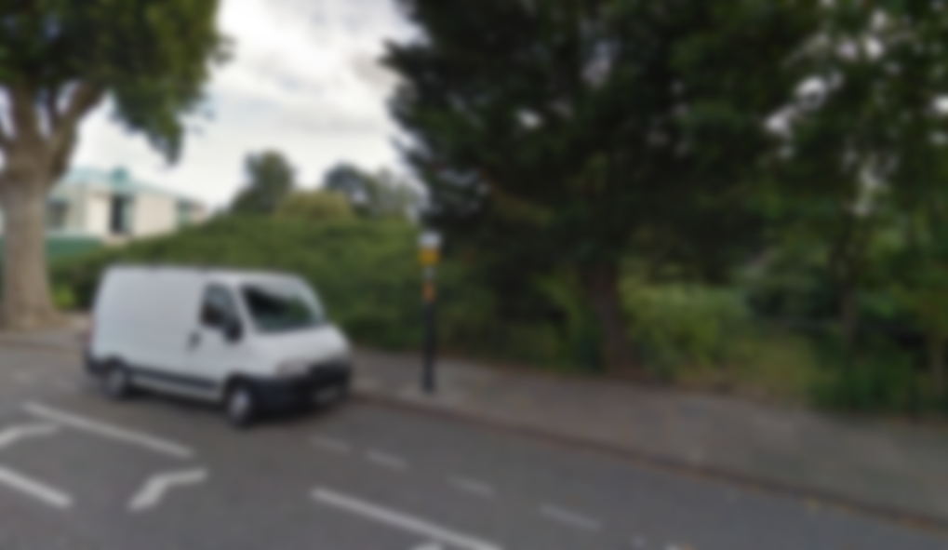

**Did you know?**

* In 2009 24% of men and 26% of woman were overweight in the UK, and these figures are increasing.
* 20% of teenagers are overweight in the UK.
* Over 20% of people have admitted that they do not exercise enough.

We aim to make a healthier, greener and happier Enfield with the introduction of an outdoor gym at the Town Park, along Cecil Road.

Green Gym Enfield

For more information visit [**www.greengymenfield.weebly.com**](http://www.greengymenfield.weebly.com) or contact us at [**greengymenfield@gmail.com**](mailto:greengymenfield@gmail.com).