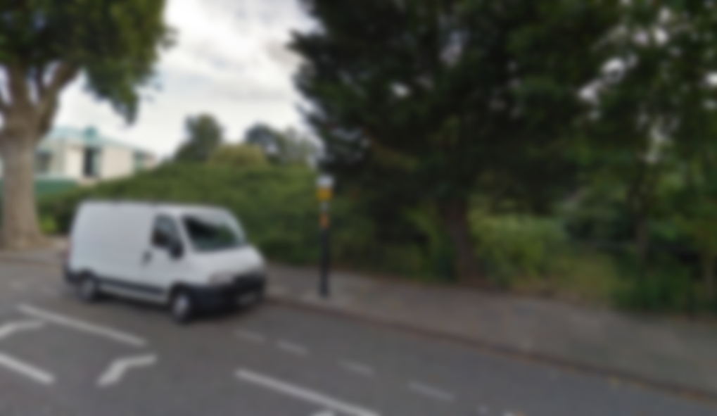

Green Gym Enfield

We aim to change these statistics and make a healthier, greener and happier Enfield with the introduction of an outdoor gym at the Town Park, along Cecil Road. But we need your help! Visit greengymenfield.weebly.com to find out more information and sign our petition!

**Did you know?**

In 2009 24% of men and 26% of woman were overweight in the UK, and these figures are increasing.