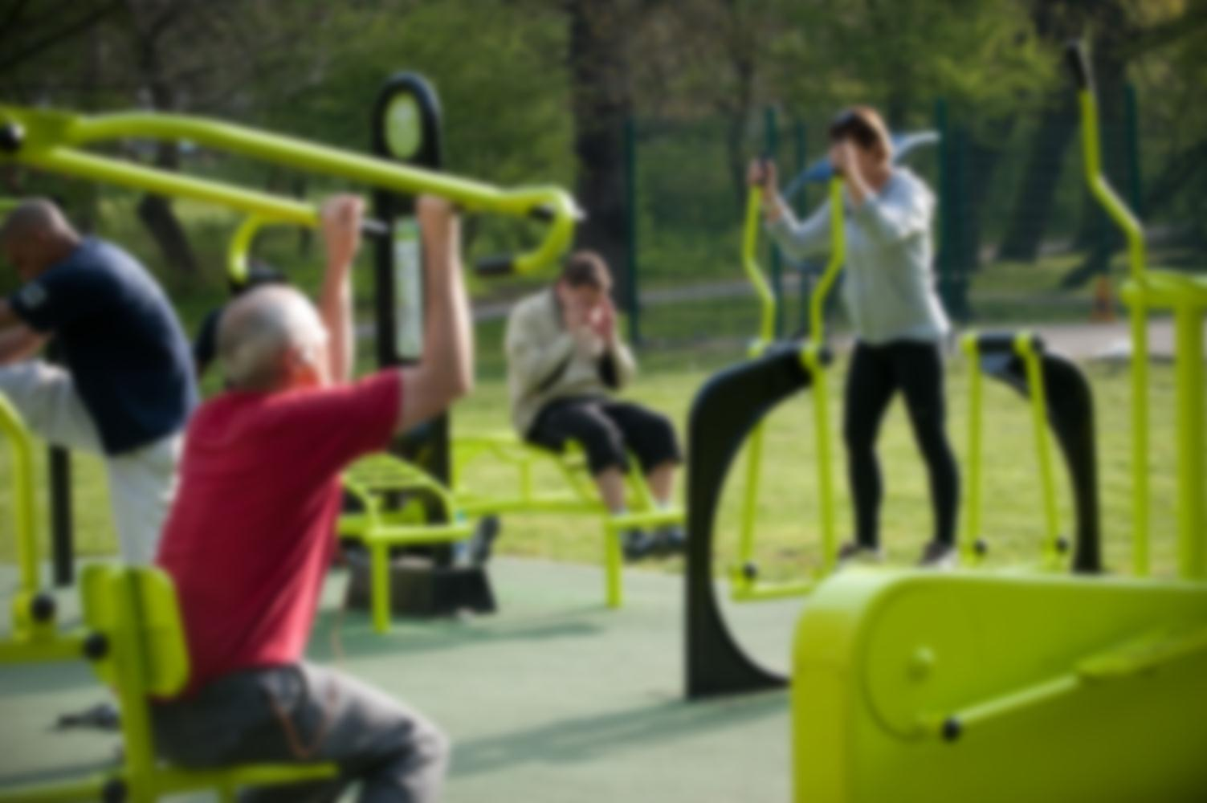

**Did you know?**

Over 20% of people have admitted that they do not exercise enough.

Green Gym Enfield

We aim to change these statistics and make a healthier, greener and happier Enfield with the introduction of an outdoor gym at the Town Park, along Cecil Road. But we need your help! Visit greengymenfield.weebly.com to find out more information and sign our petition!